McSwain:

Bill McSwain is too extreme for Pennsylvania. He celebrated the news that the Supreme Court planned to overturn Roe v. Wade. | May 2, 2022: McSwain On The Leaked SCOTUS Opinion On Roe V. Wade: “If True, This Is Of Course The Correct Decision, Both Constitutionally And Morally.” According to Bill McSwain’s tweet, “If true, this is of course the correct decision, both constitutionally and morally. But this leak is an outrageous attack on the Court.” [Twitter, @McSwainPA, 5/2/22]  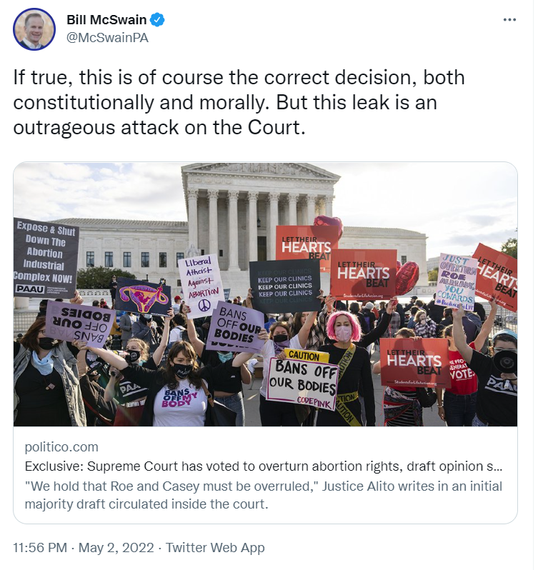  [Twitter, @McSwainPA, 5/2/22]
He’s promised that, if elected, he would “happily” sign one of the most extreme abortion bans in the country. | AUDIO: McSwain: “If The Legislature Decides That They Want To Have A Bill That Prevents Abortion At 15 Weeks, 13 Weeks, Heartbeat, Whatever It Is, It Gets- If It Undergoes Vigorous Debate. [...] I Would Happily Sign It.” According to the transcript of Bill McSwain’s meet and greet at Carlisle, “[1:02:27] BILL MCSWAIN: But I would sign any pro-life legislation that is debated and passed by the legislature, which is the voice of the people. If the legislature decides that they want to have a- a bill that prevents abortion at 15 weeks, 13 weeks, heartbeat, whatever it is, it gets- if it undergoes vigorous debate. And the people have sent their representatives there to debate that and vote on it. I would sign it. I would- I would happily sign it. But it has to be something that the legislature and the governor [inaudible] together.” [Carlisle Meet & Greet, AUDIO, 3/11/22]  As Of April 2022, 3 States Attempted To Ban Pregnancy Throughout The Pregnancy And 8 States Attempted To Ban Abortion At 6 Weeks. According to the Guttmacher Institute, “3 states attempted to ban abortion throughout pregnancy. 8 states attempted to ban abortion at 6 weeks LMP, based on the presence of a fetal heartbeat.” [Guttmacher Institute, 4/21/22]
McSwain even said he would support a total abortion ban in Pennsylvania and believed overturning Roe v. Wade was “the right decision.” | WHYY: “Barletta And McSwain Said They Support Total Abortion Bans.” According to WHYY, “Barletta and McSwain say they support total abortion bans, but would also support those limited exceptions.” [WHYY, 4/28/22]  VIDEO: McSwain: “And I Believe That Roe V Wade Will Be Overturned By The Supreme Court This Year. And You Don't Even Have To Be Pro Life To Think That's The Right Decision.” According to a transcript of the Republican Debate at New Castle, “[19:45] BILL MCSWAIN: I'm a family man with four children. I am pro life. I will have a pro life administration where pro life voices will have prominent seats at the table. I will sign legislation that protects life. And I believe that Roe v Wade will be overturned by the Supreme Court this year. And you don't even have to be pro life to think that's the right decision. You just have to be pro constitution. Because Roe v Wade is not grounded in the Constitution. I think we should also encourage adoption as an alternative to abortion. Everybody knows couples, who want to have children, who want to have a family, but for various reasons, they can't have biological children. So that's very important that we encourage adoption. And I would sign any laws, that it's constitutional that comes to me as part of the democratic process after debate in the legislature. It is not my job. It would not be my job as Governor, to be a king who thwarts the will of the people. It will be my job to promote the will of the people which is exactly what I would do.” [Republican Debate at New Castle, VIDEO, 1/13/22]
McSwain’s extreme anti-abortion position is out-of-step with the vast majority of Americans. | January 2022: 72% Of Surveyed Americans Were Opposed To Overturning Roe V. Wade. According to a Marquette University press release, “A new Marquette Law School Poll national Supreme Court survey finds that, among those with an opinion on Roe, 28% say they are in favor of overturning the decision and 72% are opposed to overturning it. The case before the Court that includes argument for overturning Roe, Dobbs v Jackson Women’s Health Organization, concerns a Mississippi law that restricts abortion after 15 weeks of pregnancy. Asked about that specific restriction, among those with an opinion, 49% favor that limitation on abortion, while 51% oppose it.” [Marquette University, Press Release, 1/26/22]  January 2022: 72% Of Americans Surveyed Opposed The Texas Six Week Abortion Ban. According to a Marquette University press release, “A Texas law, Senate Bill 8 (SB-8), is favored by 28% and opposed by 72% of those with an opinion about the law. SB-8 bans abortions after about six weeks of pregnancy, once fetal cardiac activity can be detected, and authorizes individual citizens to sue those who aid others in getting an abortion. In this survey, 81% say they have an opinion about this law. In November, 30% of those with an opinion favored the law, while 70% opposed it. In November, 84% had an opinion on this issue..” [Marquette University, Press Release, 1/26/22]

