Barletta

Lou Barletta has a long, extremist record on abortion rights. Barletta called the news that the U.S. Supreme Court planned to overturn Roe v. Wade a “victory.” | Barletta On The News That The Supreme Court “Voted To Overturn Abortion Rights:” “If This Is True, It Would Be An Enormous, Life-Saving Victory For Unborn Children.” According to Lou Barletta’s tweet, “If this is true, it would be an enormous, life-saving victory for unborn children.” Barletta shared a Politico article, “Exclusive: Supreme Court has voted to overturn abortion rights, draft opinion shows.” [Twitter, @RepLouBarletta, 5/2/22]  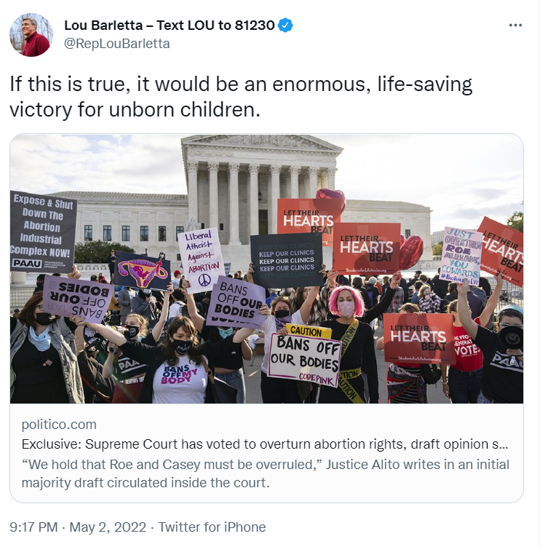  [Twitter, @RepLouBarletta, 5/2/22]
His vision for Pennsylvania includes a future where abortion is banned and performing an abortion is criminalized – leaving women without a right to their own bodies. | The Philadelphia Inquirer: “Mastriano, Barletta, And White Said A Doctor Who Violates An Abortion Ban Should Be Held Criminally Liable.” According to the Philadelphia Inquirer, “Mastriano, Barletta, and White said a doctor who violates an abortion ban should be held criminally liable.” [The Philadelphia Inquirer, 5/3/22]  VIDEO: In Response To Being Asked If A “Doctor Who Performs [An Abortion] Should Be Punished,” Barletta Responded, “Yes.” According to a transcript of the Republican debate on ABC 27, “[37:39] DENNIS OWENS: Thank you, Mr. Barletta, in 30 seconds, should a woman who has an abortion or a doctor who performs one be punished under a governor by law? [37:45] LOU BARLETTA: Nah, I believe the woman should be counseled. We should do counseling prior to, as well as after, and as for a doctor? Yes.” [ABC 27, VIDEO, 4/27/22]  WHYY: “Barletta And McSwain Said They Support Total Abortion Bans.” According to WHYY, “Barletta and McSwain say they support total abortion bans, but would also support those limited exceptions.” [WHYY, 4/28/22]
During a debate, Barletta touted his “100% voting record” on anti-abortion legislation… | VIDEO: Barletta: “I Have A 100% Voting Record So You Know My Record Is Very Clear.” According to a transcript of the Republican debate on ABC 27, “[35:12] LOU BARLETTA: Yeah I have a 100% voting record so you know my record is very clear. People can read it. I have a 100% voting record for life. I have been pro life in every, every opportunity I have. As a governor, I would sign any bill that comes to my desk that would, would protect the life of the unborn and I have made exceptions for rape, incest, and the life of the mother.” [ABC 27, VIDEO, 4/27/22]  VIDEO: Barletta: “I Would Sign Any Bill That Comes To My Desk That Would Protect The Life Of The Unborn.” According to a transcript of the Republican debate on ABC 27, “[35:12] LOU BARLETTA: Yeah I have a 100% voting record so you know my record is very clear. People can read it. I have a 100% voting record for life. I have been pro life in every, every opportunity I have. As a governor, I would sign any bill that comes to my desk that would, would protect the life of the unborn and I have made exceptions for rape, incest, and the life of the mother.” [ABC 27, VIDEO, 4/27/22]
…– which included co-sponsoring a 6 week abortion ban that would ban abortion before most women know they are pregnant. | In 2018, Barletta Co-Sponsored A Heartbeat Bill In Congress, “Which Would Effectively Ban Abortion After Six Weeks Of Pregnancy.” According to the Washington Post, “The targets in those states will be Republicans who cast low-profile antiabortion votes, often on bills that were throttled by the Senate, but who represent districts with pro-abortion rights voters who often sit out midterm elections. Several, such as Rep. Steve Knight (R-Calif.), Rep. Mike Bishop (R-Mich.) and Rep. Steve Chabot (R-Ohio) are co-sponsors of the so-called “Personhood” bill, which would take aim at Roe v. Wade by legally stating that life begins at conception. Others have sponsored the “heartbeat” bill, which would effectively ban abortion after six weeks of pregnancy. Two sponsors of the latter bill, Pennsylvania’s Lou Barletta and Ohio’s James B. Renacci, are candidates for the Senate.” [The Washington Post, 5/24/18]  A Six Week Abortion Ban Would Ban Abortion “Well Before Many Women Even Know They Are Pregnant.” According to NPR, “The Texas law, passed in May, bans all abortions in the state after about six weeks of pregnancy — well before many women even know they are pregnant.” [NPR, 9/1/21]
He also stated that if he was elected Governor, a doctor should be punished for performing an abortion. Women, not politicians, should control their bodies. | The Philadelphia Inquirer: “Mastriano, Barletta, And White Said A Doctor Who Violates An Abortion Ban Should Be Held Criminally Liable.” According to the Philadelphia Inquirer, “Mastriano, Barletta, and White said a doctor who violates an abortion ban should be held criminally liable.” [The Philadelphia Inquirer, 5/3/22]  VIDEO: In Response To Being Asked If A “Doctor Who Performs [An Abortion] Should Be Punished,” Barletta Responded, “Yes.” According to a transcript of the Republican debate on ABC 27, “[37:39] DENNIS OWENS: Thank you, Mr. Barletta, in 30 seconds, should a woman who has an abortion or a doctor who performs one be punished under a governor by law? [37:45] LOU BARLETTA: Nah, I believe the woman should be counseled. We should do counseling prior to, as well as after, and as for a doctor? Yes.” [ABC 27, VIDEO, 4/27/22]

